Building method on Windows 10

Source folder name is BladeRF. This is latest clone of <https://github.com/Nuand/bladeRF>, and can be used for Ubuntu build.

1. Make folder called “build” in “host”.

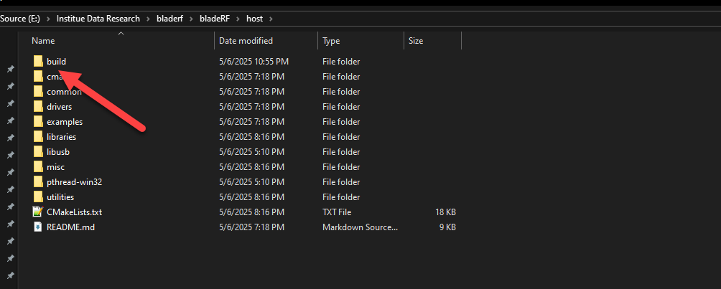

2. Run Cmake and select source and build folder.

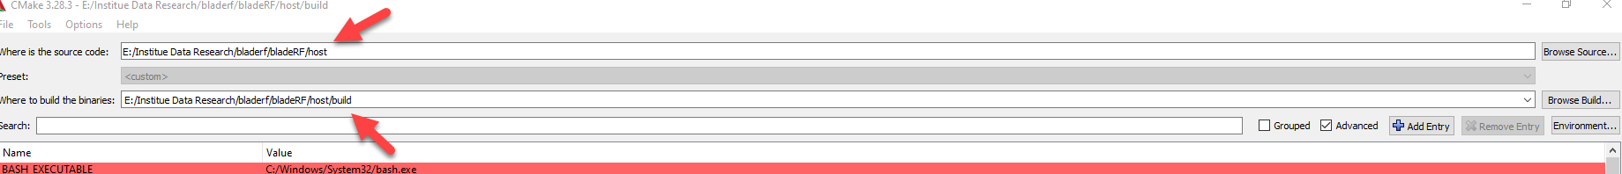

3. select VS2019 and x64.

4. Click “configure”. If you get error, you need to select path of libusb and pthread.

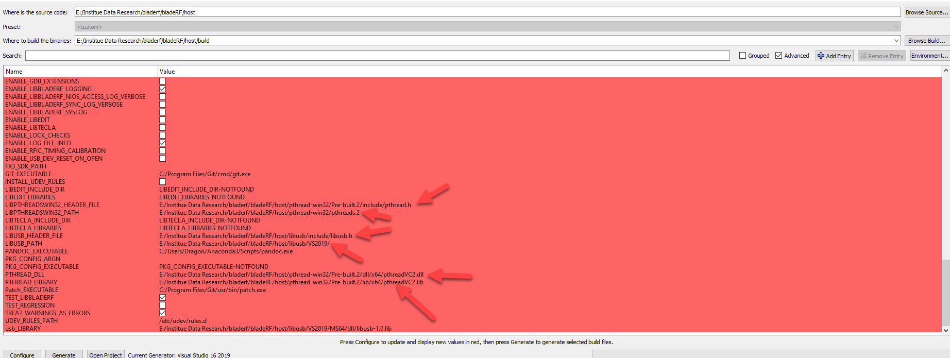

5. If configuration is success, then, generate and open project.

6. Build project.

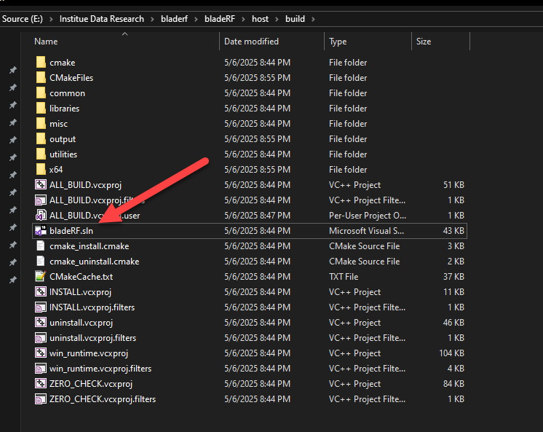

7. If you get error when build, you need to set “Treat Warnings as Errors” as “No” for bladeRF-cli and libbladerf_shared project.

